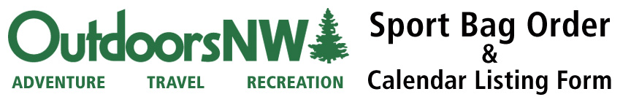

**CALENDAR LISTING** – Get your event listed in the *OutdoorsNW* event calendar – in [print](http://www.pageturnpro.com/Price-Media,-Inc/50560-Outdoors-NW-Annual-Event-Guide-2013/index.html#22) and [online](http://outdoorsnw.com/event/). It’s the Northwest’s comprehensive list of outdoor events! **Please fill out ONE form for EACH event.**

Event name:

Type:       (Bicycling, Mountain Biking, Running, Marathon, Run/Walk, Hiking, Festival, Multisport, Adventure, Winter Sports, Water Sport, Clinics/Classes)

Date:       Start time:       Participants Expected:       Event Cost:

City, State:       Event phone:      Event Web Address:

Email Address:

Tell us about your event (starting location, distances, beneficiary, special attractions, etc.):

**EVENT DIRECTOR INFORMATION** – Who can wecontact for additional information?

Contact:       Organization/Group:

Day Phone:       Eve. Phone:       Fax:       Email:

Mailing Address:

City:       State:       Zip:

**SPORT BAG ORDER FORM** – *OutdoorsNW* *magazine* Sport Bags are **FREE** for Northwest event directors. To learn more about how the Sport Bag program can support your event call 206-418-0747.

Number of participants expected at this event:       Number of Sport Bags requested:

In order to prevent sponsor conflicts, please list your primary sponsors:

**Option 1 –** Self pick-up (FREE! North Seattle location)

Self Pick-up Date:       Self Pick-up Time:

**Pick-up location:**

[10312 Wallingford Ave. N.](https://maps.google.com/maps?q=10312+wallingford+ave+N&ie=UTF-8&ei=tAJrUv6_KqaAiwKA6oGoBw&ved=0CAoQ_AUoAg)

Seattle WA, 98133

Basement floor of 2-story house

(206) 418-0747 for questions or directions

**Option 2** **–** UPS Delivery Mail .25 to .30 cents/bag. Call (206) 418-0747 for a quote. Pre-payment required for shipping.

Mailing Address       City       State       Zip       Contact Person       Phone

Credit Card Type       Credit Card Number       Expiration Date